The FAA CSA supports, either entirely or portions of the following (see attached map):

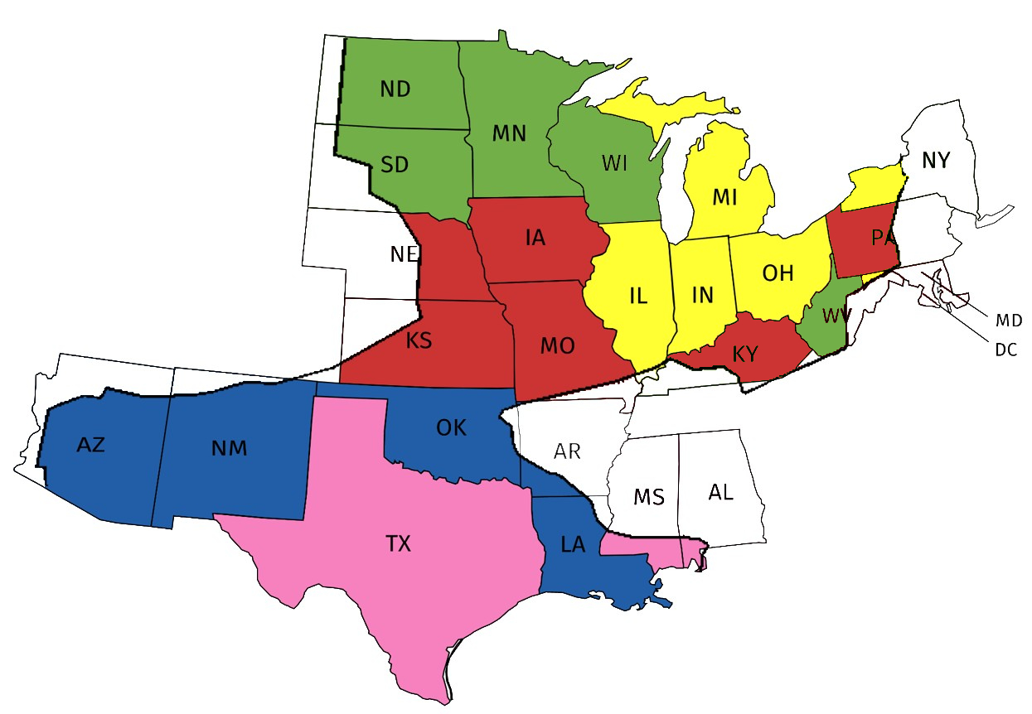

Arkansas (AR) | Michigan (MI) | Ohio (OH)
Arizona (AZ) | Minnesota (MN) | Oklahoma (OK)
Illinois (IL) | Missouri (MO) | Pennsylvania (PA)
Indiana (IN) | Mississippi (MS) | South Dakota (SD)
Kansas (KS) | North Dakota (ND) | Texas (TX)
Kentucky (KY) | New Mexico (NM) | Wisconsin (WI)
Louisiana (LA) | New York (NY) | Wyoming (WY)
Maryland (MD)

